Biz Data
Can AI-Powered Virtual Assistants Crack the Language Barrier?
Minnesota leveraged Google AI to create a multilingual virtual assistant. Data from a records request reveals how it’s really being used by a diverse population and potential limitations with the technology.
Nikki Davidson
January 23, 2024
https://www.govtech.com/biz/data/can-ai-powered-virtual-assistants-crack-the-language-barrier

Shutterstock
Last year Minnesota launched a groundbreaking new tool for government, an AI-powered virtual assistant that could translate driver and vehicle processes into four different languages. Now, there’s new data about how it’s being used, after public records requests placed by Government Technology.
The Minnesota Driver and Vehicle Services (DVS) virtual assistant was introduced on the agency’s website in March of 2023, making it the first state government virtual assistant for driver and vehicle services to translate to Hmong and Somali as well as English and Spanish. The tool leverages Google Enterprise translation technologies to allow online visitors to ask questions, gather information and research topics.
DVS Director Pong Xiong is a member of the Hmong community, and he said he’s seen firsthand how difficult navigating the government can be for his family and friends who don’t speak English.
“As a new American, you do feel very small when you can’t do things on your own,” Xiong said. “What this tool does is allow Minnesotans to independently interact with DVS, and I think that’s one step in the right direction for our communities.”
According to data from the Minnesota Department of Education, more than 1 in 10 Minnesotans don’t speak English.
The DVS virtual assistant is still in beta mode while other portions are being developed, but it had a total of 87,813 conversations from its launch March 1 through the end of 2023.
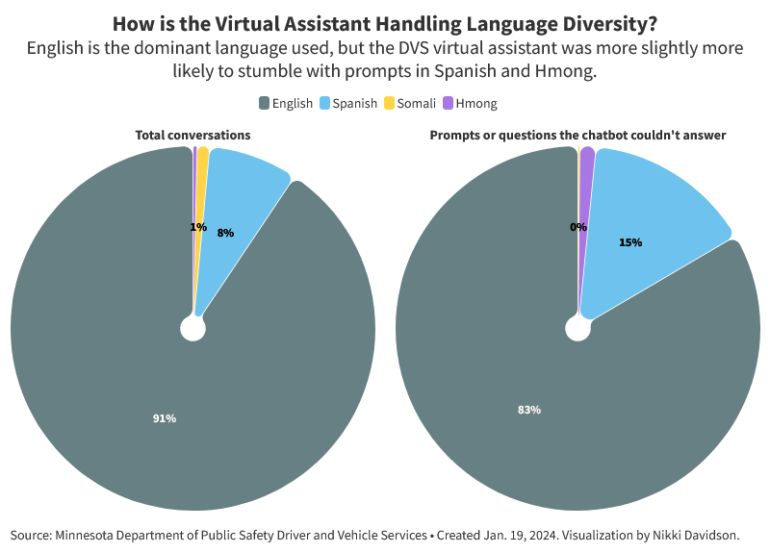
During that time, a large majority, nearly 91 percent, of those conversations were in English, nearly 8 percent were in Spanish, 1 percent in Somali and less than 0.5 percent were in Hmong.
Out of all prompts or questions put into the virtual assistant, 6 percent did not have a matching response. When comparing total conversations versus prompts or questions that did not match a response in the virtual assistant, Spanish and Hmong questions or prompts had a slightly higher rate of not matching a response than their overall portion of total conversations.
The slight difference suggests Minnesota is continuing to work through some of the challenges that come with programming a multilingual virtual assistant. Xiong explained in 2023 that Hmong is a young written language, so there’s a limited amount of content to train the tool on, making translation of common terms more difficult, especially when dealing with technical jargon.
To program the assistant, DVS put all of its customer-facing correspondence, 499 documents, through a plain language process to make them as clear and succinct as possible to translate into other languages. The content was first machine-translated, then reviewed by certified translators and also reviewed by members of the local Minnesota community in each language. The project involved extensive community feedback, engaging more than 290 people including vehicle owners, college students, K-12 parents and students.
Usage data also revealed how users of the languages interact with the tool in different ways. People who speak Somali were more likely than people who speak English to use the FAQ feature, while people who speak Hmong were more likely to use the self-service options. The differences could be due to cultural preferences, or it might hint that additional work is needed to make the tool’s self-service features more accessible to speakers of all languages.
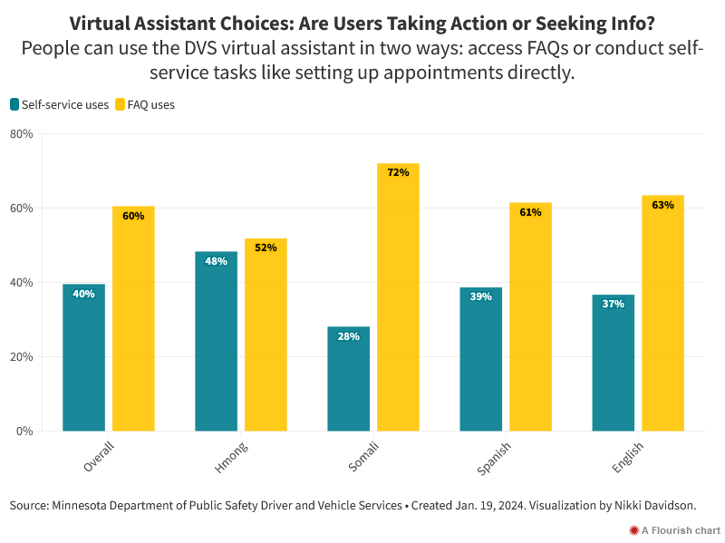
DVS shared the top 10 topics searched in the virtual assistant, listed in order of frequency:
- CDL road tests
- Exam appointments
- Road test questions
- Class D knowledge tests
- Tab renewal
- Cancel or reschedule appointments
- Written exam
- Driver evaluation
- eServices for business
- Vehicle refund
The list suggests that career truck drivers, bus drivers, construction drivers and potential career switchers are often using the virtual assistant to get access to information about obtaining or maintaining a commercial driver’s license.
Several other cities are experimenting with multilingual chatbots, as the number of people who speak a language other than English at home continues to grow in a majority of states in the country.
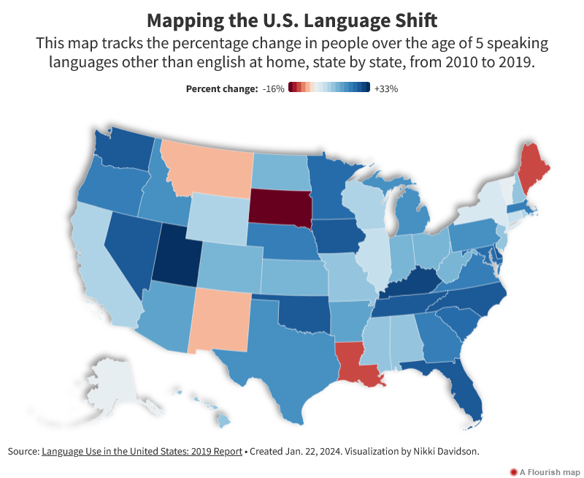
As Minnesota continues to develop new capabilities for the DVS virtual assistant, the state stressed that it’s critical to continue to connect with the communities that use it to improve its features.
“Being nimble and flexible is important as we adjust to our customers’ needs,” Xiong said. “Our goal is to help all state residents know they matter as community members, and that state agencies are partners in building one Minnesota for people of all backgrounds.”
In the future, DVS is working to add more languages to the assistant, as well as leverage voice artificial intelligence technology.

