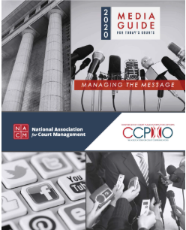
NACM and CCPIO encourage courts to take a positive approach and proactive role in managing relations with the media. The media play an important role in informing the public about the business of the courts. The successful fulfillment of courts’ purposes and responsibilities depends greatly upon public trust and confidence in the courts and the support of other branches of government, without which the legitimacy of court decisions may be questioned and the resources and conditions needed for judicial independence may be lost. Effective communication through traditional and new media enable the courts to raise their perceived social value and overall performance. It is the wish of our associations that this guide be a helpful resource to court professionals.
Free to NACM Members.
$10 for non-members

